Theme: If it's not safe or you’re unsure - stop!​
Thank you for attending today’s Safety Reset. Remember this day is about you and your safety, health and wellbeing – so please participate in the discussions.
We hope you have a chance to listen, learn and contribute.
This information sheet contains the key take away information you may want to keep for future reference.

Feedback survey
Visit www.surveymonkey.com/r/SR-attendee (or scan the QR Code over the page) to complete the simple online survey before you leave today, or as soon as possible.

Laws that support you to report
Go to www.legislation.qld.gov.au/browse/inforce and search or scan the QR Codes over the page:
- Mining and Quarrying Safety and Health Act 1999 (section 253)
- Coal Mining Safety and Health Act 1999, (section 274)
- Explosives Act 1999, (section 126a)
- Work Health and Safety Act 2011, (section 84)
- Petroleum and Gas (Production and Safety) Act 2004, (section 708c)

Reporting
Report your concerns through your site’s channels first.
If you feel your concerns have not been addressed, contact the appropriate Inspectorate at Resources Safety and Health Queensland to escalate your concerns. Our contact details at www.rshq.qld.gov.au/contact or scan the QR Code over the page.

Some ‘light’ reading
- Brady review of all fatal accidents in Queensland mines and quarries from 2000 to 2019 https://documents.parliament.qld.gov.au/tableOffice/TabledPapers/2020/5620T197.pdf
- Coal Mining Board of Inquiry www.coalminesinquiry.qld.gov.au/

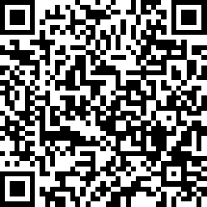 | 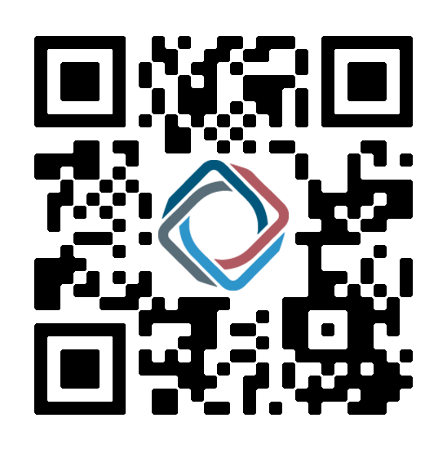
Attendee Feedback Survey | RSHQ Contacts
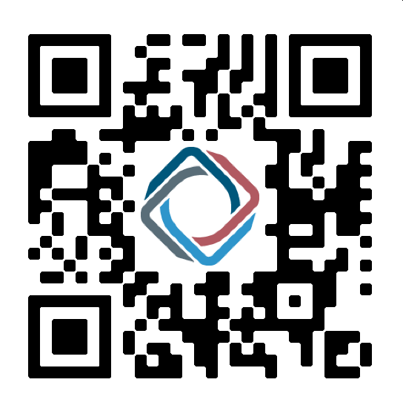 | 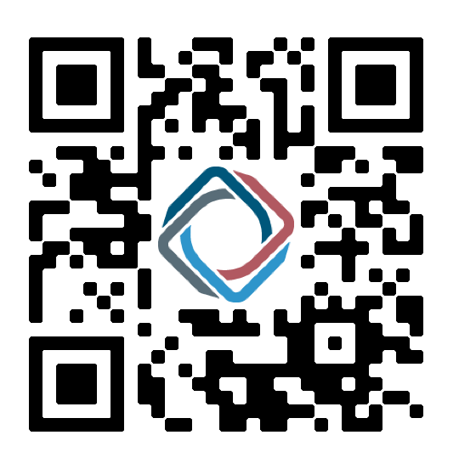
Coal Mining Health and Safety Act 1999 | Explosives Act 1999
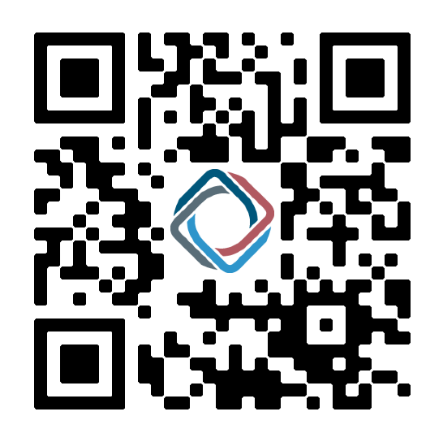 | 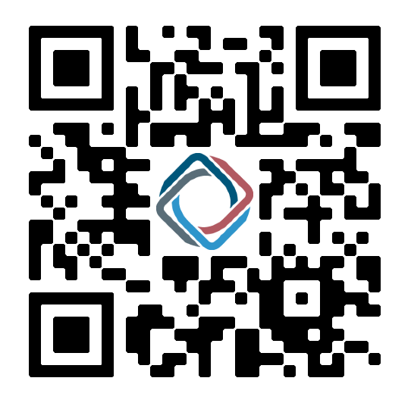
Petroleum and Gas (Production and Safety) Act 2004 | Mining and Quarrying Safety and Health Act 1999

